MATHEMATICS DEPARTMENT 2015
Year 11 Specialist - Test Number 5
Trigonometric Identities and Complex Numbers


Name: _______________________________ Teacher: DDA
Marks: 50
Time Allowed: 45 minutes
Instructions: You are permitted 1 page notes but no calculator.
_________________________________________________________________________
Part A
8 multiple-choice questions
1 mark each: 8 marks
Circle the correct answer.
1 sec (60°) =
A 2
B
C
D
E
[1 mark]
2 sin =
A −2
B
C
D
E

[1 mark]
3 sin (90° + α) =
A sin (α)
B −sin (α)
C cos (α)
D −cos (α)
E sin (90°)

[1 mark]
4 The graph shown below could have the equation:
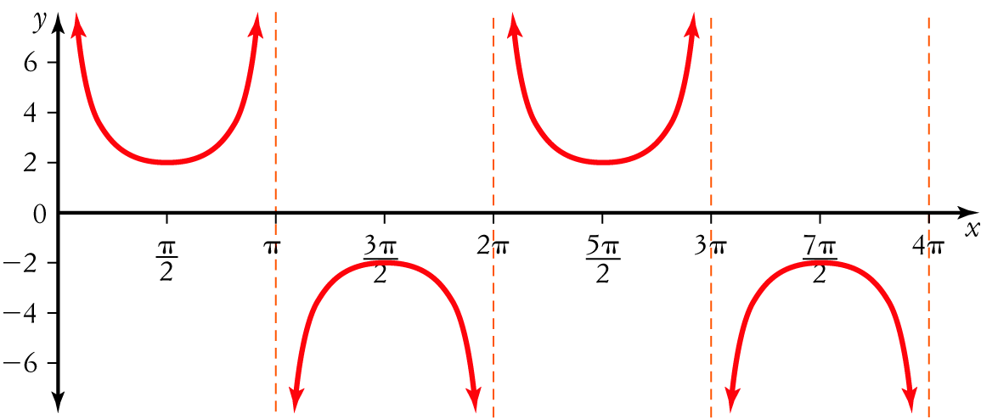
A y = 2 cosec (x)
B y = 2 sec (x − 1)
C y = cosec (x)
D y = sin (x)
E y = cosec

[1 mark]

5 mod =
A 4
B –2
C
D 2
E 2i

[1 mark]

6 The value of is:
A i
B 1
C –1
D –i
E
[1 mark]

7
A 3 – i
B –3 – i
C –3 + i
D 3 + i
E 3 + 3i
[1 mark]

8 The solutions to the quadratic equation x2 + 16 = 0 are:
A
B ±4
C ±4i
D
E ±2i

[1 mark]

Part B
10 short answer questions
29 marks
Show your working where appropriate.

9 Express the following in the form a+bi:
[2 mark]

10 A quadratic equation has roots . Express it in the form $ax^{2}+bx+c=0$
[2 mark]

11 Sketch the graph of y = −sec (x) + 1 for 0 ≤ x ≤ 4π.
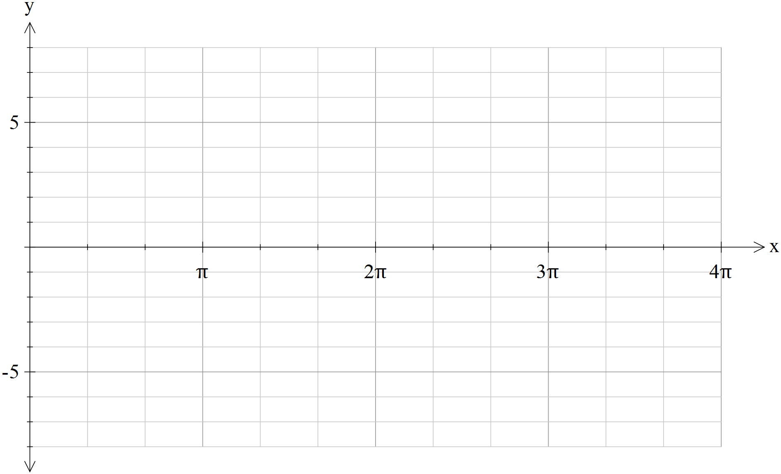 [4 marks]

The grids below this point are for you to use to assist in your thinking on paper. Nothing below this sentence on this page will be marked and there use is optional.
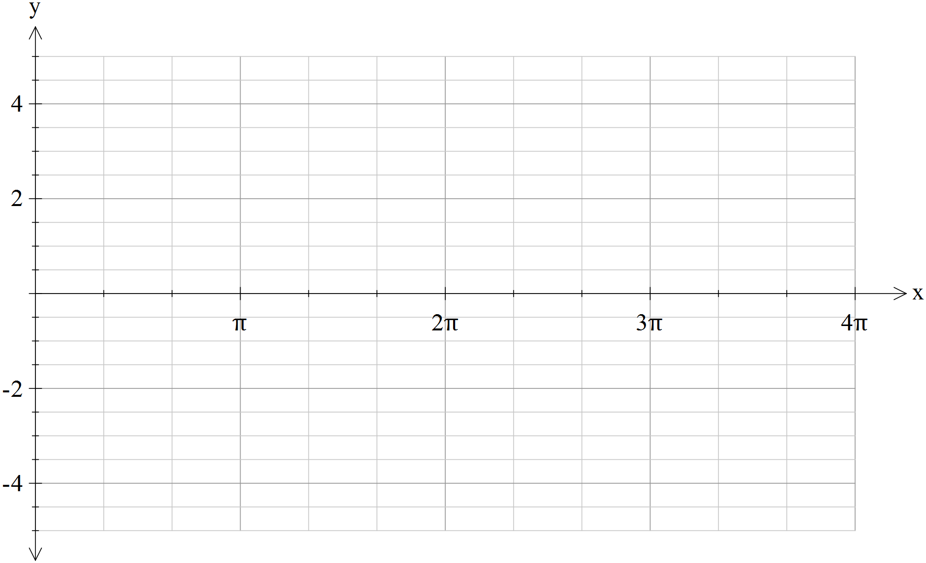
12 Using the Pythagorean identity sin2 (θ) + cos2 (θ) = 1 evaluate cos2 given that sin.

[3 marks]
13 Using a suitable compound angle formula evaluate tan .
[4 marks]
14 Express cos (60°) cos (15°) as a sum. DO NOT evaluate.

[1 mark]

15 If w = 2 – 3i, the points A, B, C and D correspond to the vectors and iw. [5 marks]
a State the coordinates of the points A, B, C and D.

b Plot the points A, B, C and D on an Argand diagram.
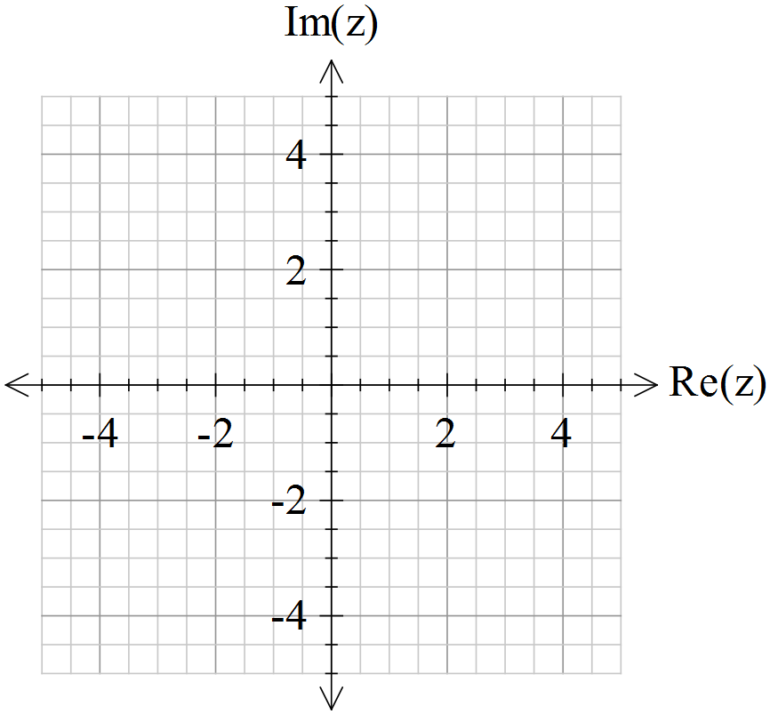

[5 marks]

16 Consider the complex numbers z = –1 + and w = .
a Find Im(z + w).

b Find Re(zw).

[4 marks]
17 Solve the equation x2 – 8x + 17 = 0 in the complex plane.
[2 marks]
18 Realise the denominator on , expressing your answer in the form a + bi, where a, b R.
[2 marks]

Part C
3 analysis questions
13 marks
Show your working where appropriate.
19 Rewrite the expression sec (x) sin (2x) − sin (x) cos (2x) in terms of sin (x) only.

[3 marks]

20 Prove that 1 + tan2 (x) = sec (x) cosec (x) tan (x).
[3 marks]

21 Prove each of the following for z = x + yi, where x, y R:
a

b

[4,3: 7 marks]
Total marks: 50

